Interactive Media – Unit 1 – LO2

Lesson 3 – Image Manipulation Basics

Tutorial

The purpose of this tutorial is to cover some of the basic tools in Adobe Photoshop. This is not an extensive tutorial, however it should equip you to make some basic manipulations to an image.

To begin, you will need an image to work on. For the sake of this tutorial, you may want to use a landscape photo, however you can use others. 

The above image is taken from the internet, however it does not have creative commons licensing. It can therefore be used for education, but you cannot use it for your own portfolio.

Once you have Photoshop, you should see a screen similar to the screenshot below. To begin modifying your phot, you need to select the **File** tab, then the **Open** button. From there, you can select the image you have saved already.

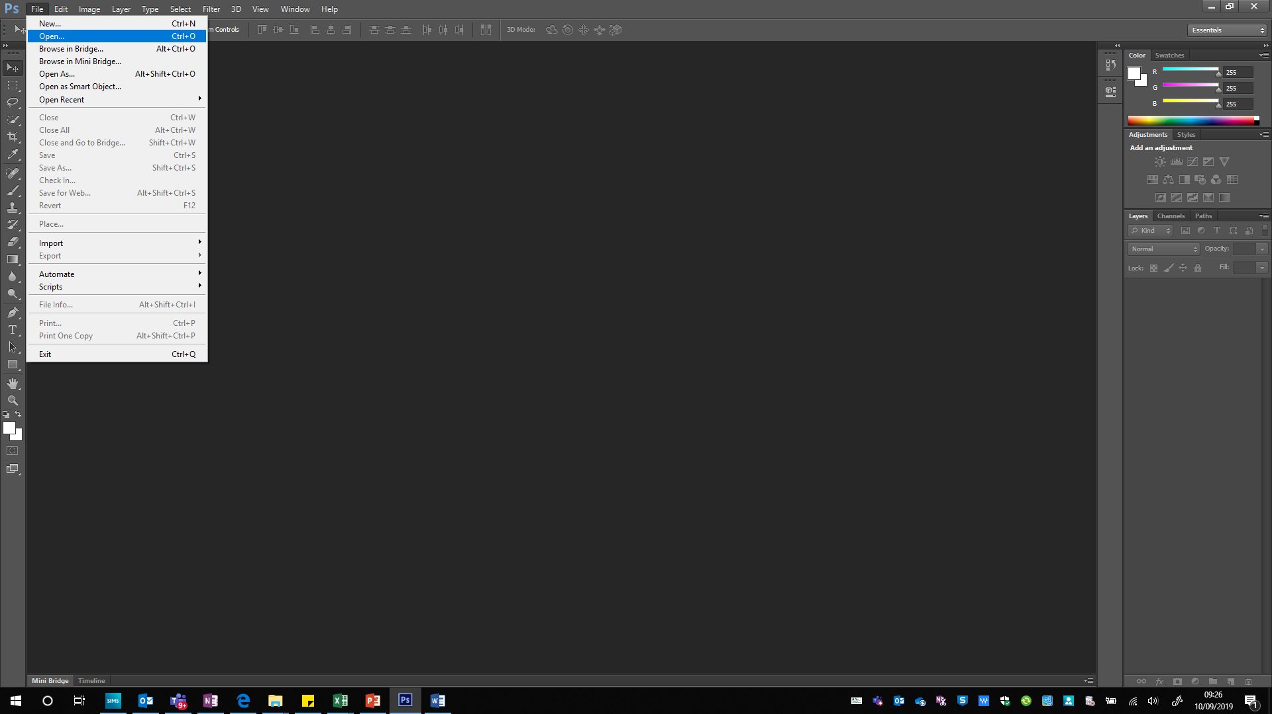

Once you have selected your image, it should now appear in the main window.

Note: To zoom in and out of the image, hold down **alt** on the keyboard and use the scroll wheel on the mouse.

At this point, the image may not fit exactly as you intend it to, so you will need to crop it to size. This is no little different to the steps you may take in other software.



Select the above tool and you will be prompted to crop the image. Remove the parts you don’t want then press the **tick** button at the top of the screen. This will remove the unwanted parts of the image and resize the canvas so that the newly cropped images fits the canvas.

At this point, the image is ready for effects to be used. There are many different effects that can be used and all can be used for different purposes. When used in conjunction with each other, they can be used to produce a variety of images. This tutorial will cover some of those effects, however you will be experimenting with these and using more to alter images to show off your skills.

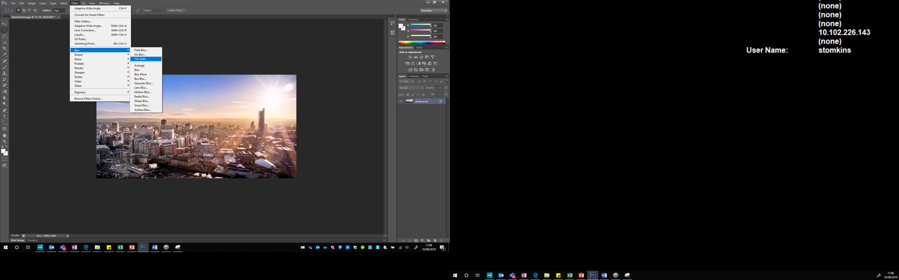

The image above shows the method to access the tilt-shift filter. This blurs some of the image in the foreground, and in the background but leaves a small section un-blurred. You may want to experiment with different blurs to see the effect they have on an image.

Select the blur filter you want to use and decide on the settings that best fit your image then press **OK** at the top of the screen to confirm the changes.

Many of the features used to adapt the entire image can be found in the **Filter** menu, you will need to do some experimentation in this area.

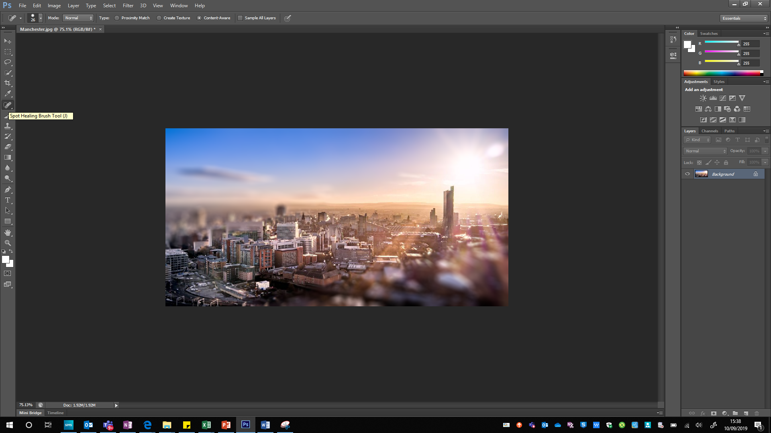

The **Spot Healing Tool** is another that is extremely useful when manipulating images, however if misused, it can be very obvious. This is best used to remove blemishes in an image where the surrounding area matches the area that needs to be filled in.

For this example image, there is a cloud still visible in the sky despite the blurring used. By selecting the tool and highlighting the area that is unwanted, that content can be removed from the original image as shown in the two images below.

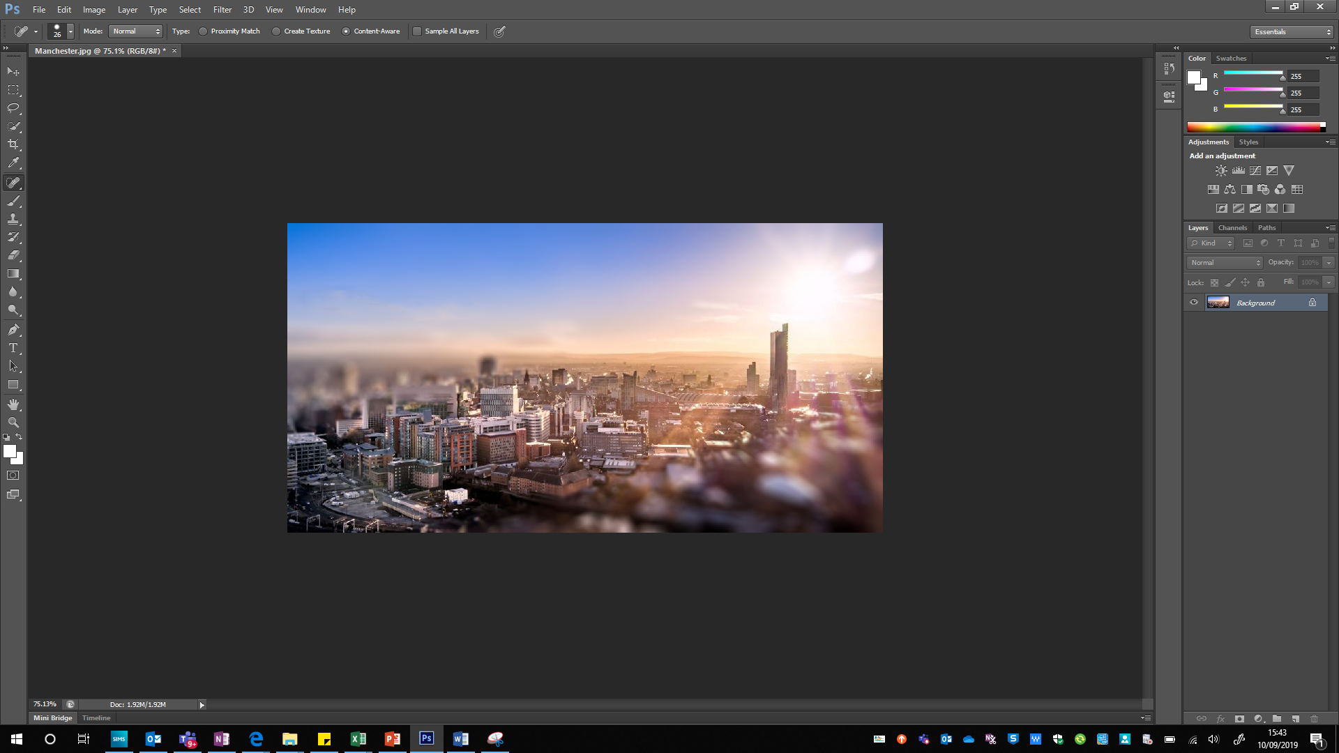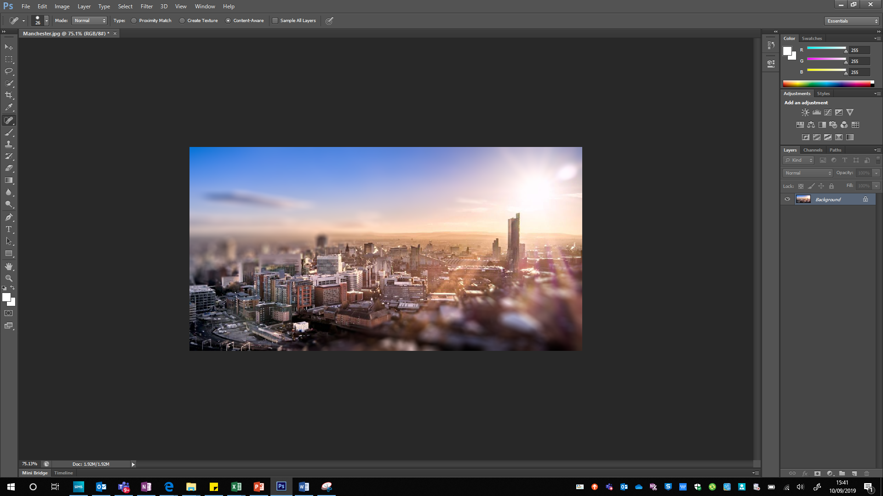

A key feature of image manipulation software is the ability to use layers. Much like using layers on a physical piece of artwork, this can be used to position elements so that they appear either in front or behind other objects.

To create a new layer, select the **new layer button** in the bottom right corner, as shown below.

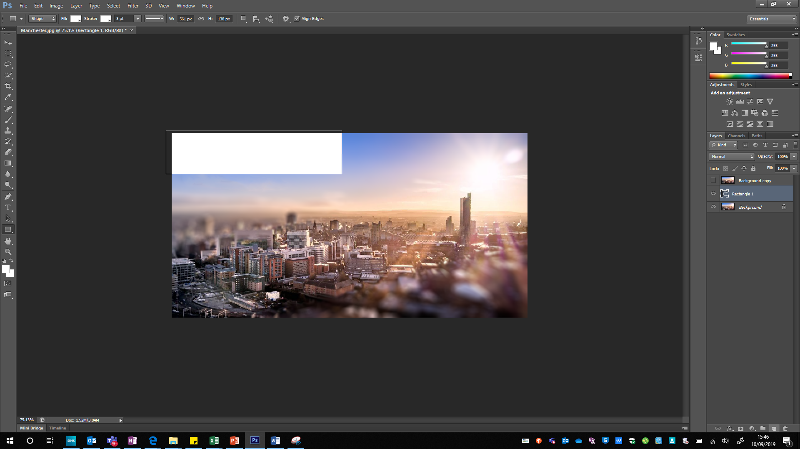

Any content added to this layer won’t have an effect on the other layers. This allows you to make changes without the risk of “damaging” the other layers.

You can toggle the visibility of a layer by selecting the **eye button** to the left of each layer. Right-clicking on a layer gives the option to **merge layer down**. This combines the current layer with the layer below. Be careful, as this can’t be undone if you have then done further work on the layer. The layer mode can also be changed. This changes how it interacts with the layer below, e.g. it can darken the layer below, lighten, invert colours etc. This can be used to create effects such as in the image below, where the text retains the background.

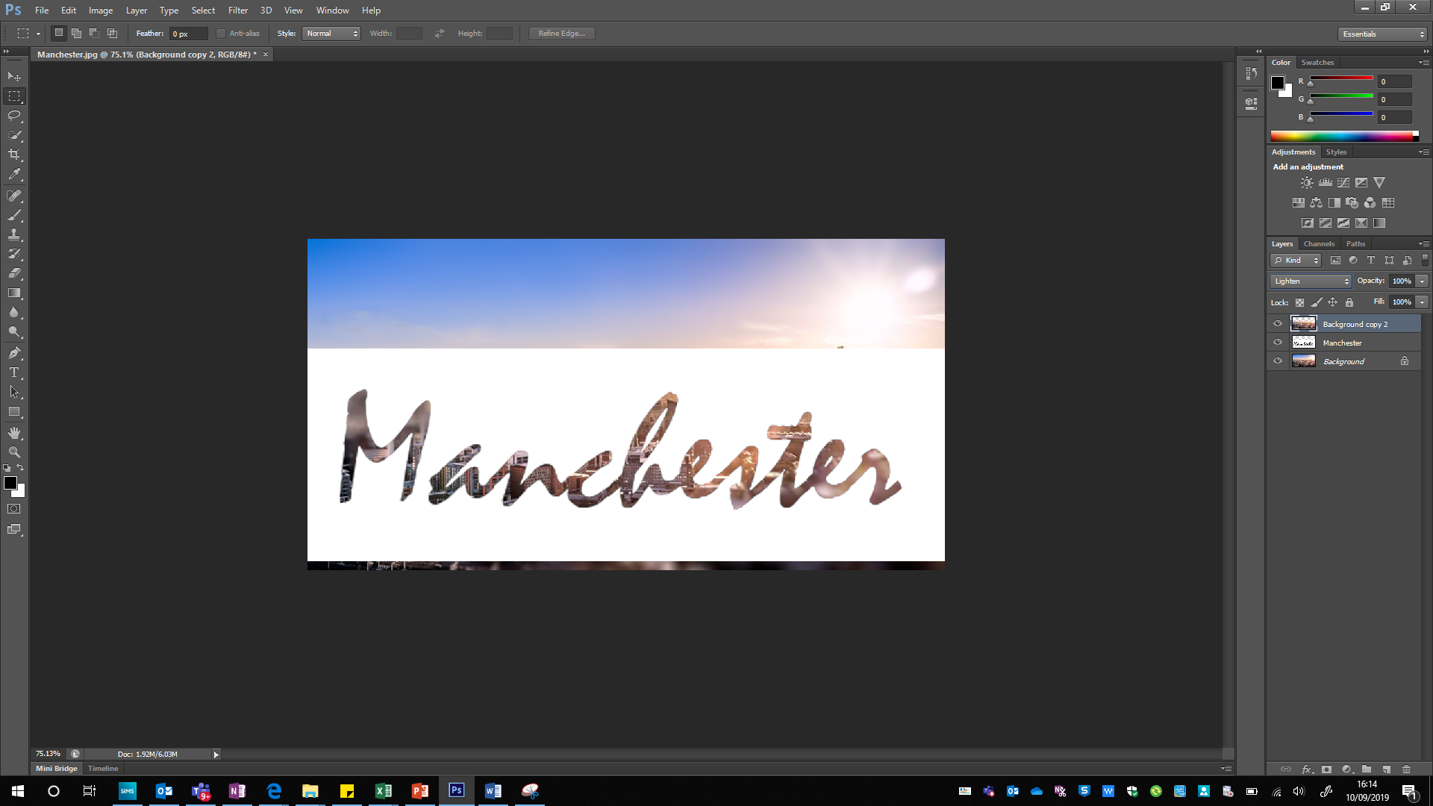

Each of the tools on the pane on the left have specific purposes, however only some will be covered in this tutorial. If you are unsure on the purpose of a tool, hover the mouse above the tool and the name will appear. You can then look up that tool on the internet.